**What is Tableau?**

Tableau is a Business Intelligence tool for visually analysing the data. Users can create and distribute an interactive and shareable dashboard, which depict the trends, variations, and density of the data in the form of graphs and charts. Tableau can connect to files, relational and Big Data sources to acquire and process data. It is also positioned as a leader Business Intelligence

Download Tableau public:

https://public.tableau.com/en-us/s/

The Free Personal Edition of Tableau public can be downloaded from [Tableau public.](https://www.tableau.com/products/desktop/download?os=windows) You need to register with your details to be able to download.

After downloading, the installation is a very straightforward process in which you need to accept the license agreement and provide the target folder for installation.

1. Visit websites
2. Download the public version
3. Start the installation

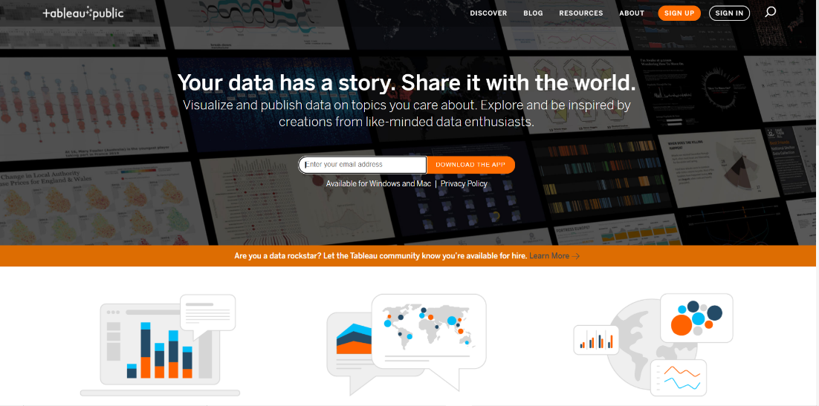

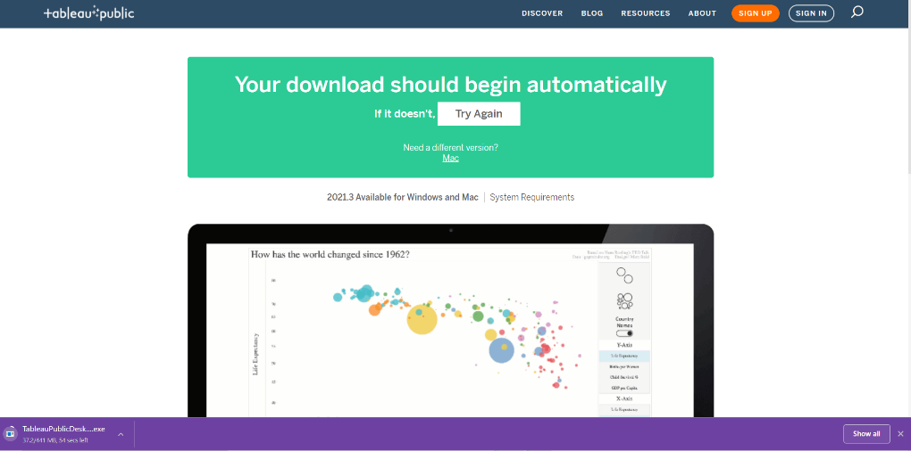

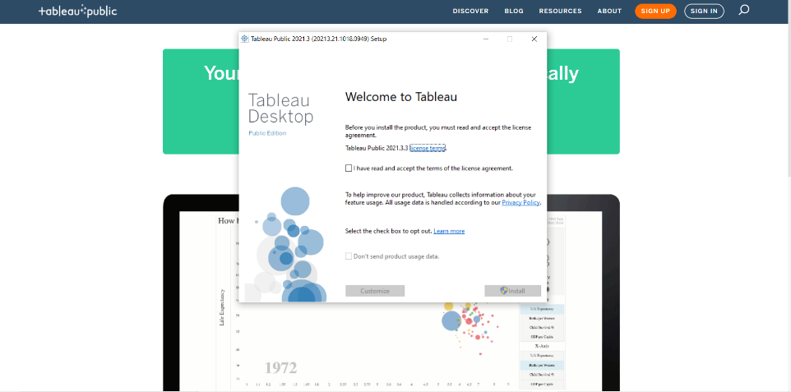v

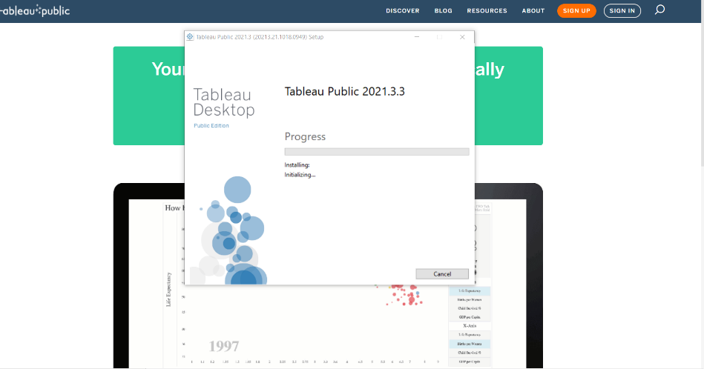

Click the Tableau icon. The following screen appears.

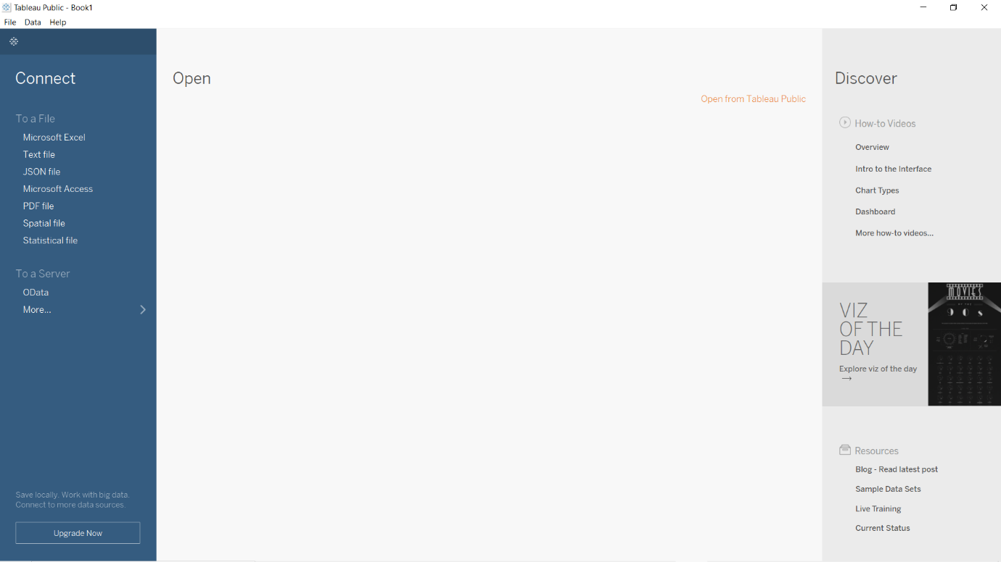

You are now ready to learn Tableau

**Procedure to load file in the Tableau**.

Click on text file option

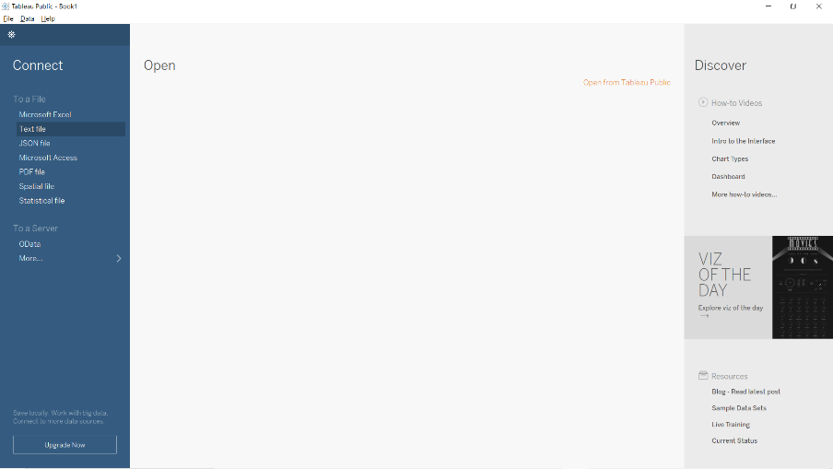

Load your file from your system

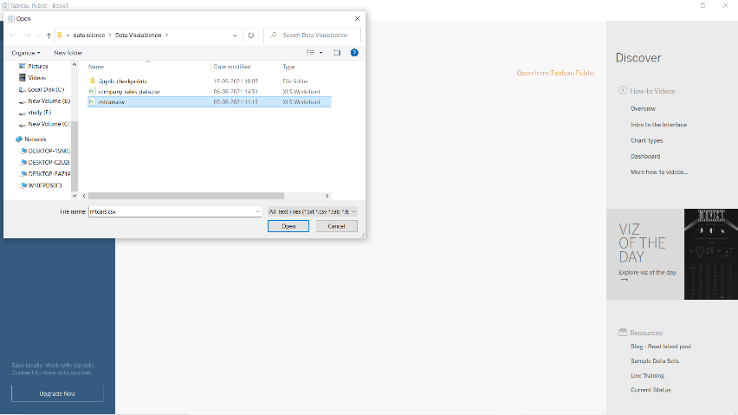

You will interface like this:

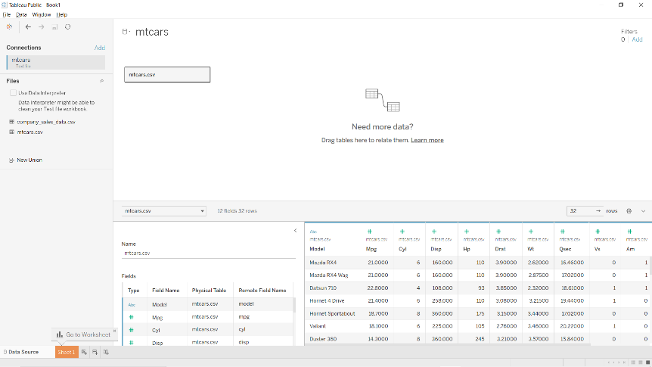

Now click on sheet 1

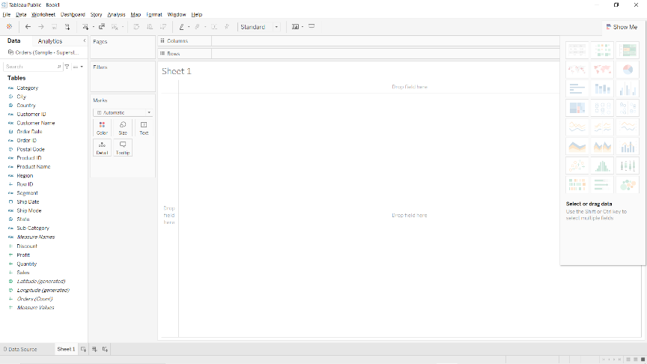

How to Drag columns and do Analysis

Next, choose the data to be analysed by deciding on the dimensions and measures. Dimensions are the descriptive data while measures are numeric data. When put together, they help visualize the performance of the dimensional data with respect to the data which are measures. Choose **Category** and **Region** as the dimensions and **Sales** as the measure. Drag and drop them as shown in the following screenshot. The result shows the total sales in each category for each region.

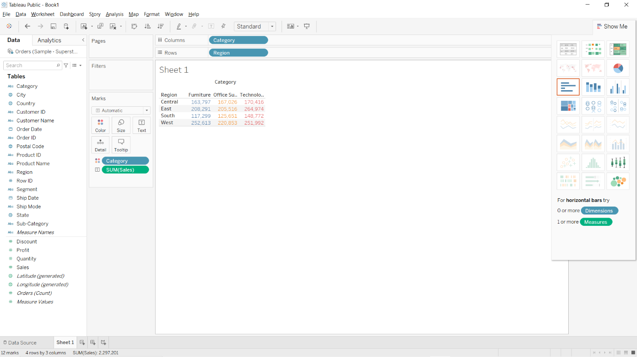

### Apply Visualization Technique

you can see that the data is available only as numbers.  you can see them as graphs or charts with different colours to make a quicker judgment.

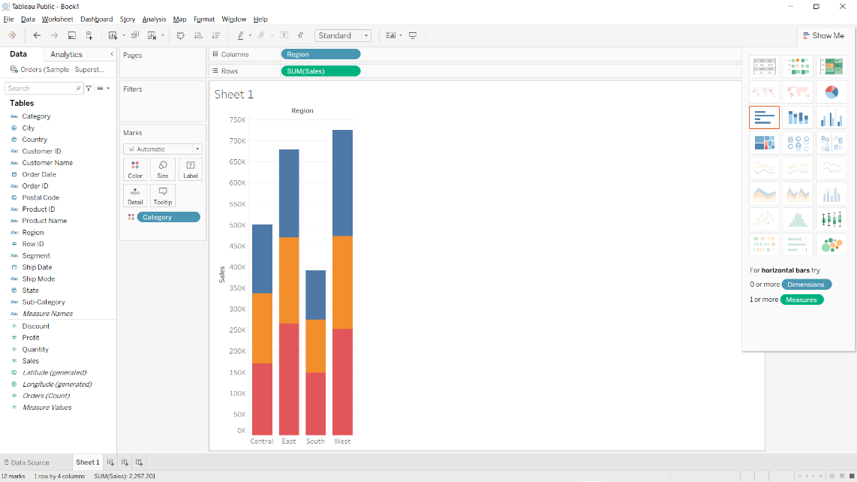

You can apply a technique of adding another dimension to the existing data. Classify according to segment

